**Module 4 Assignment**

1. Write a PHP function to sort an array of strings by their length, in ascending order. (Hint: You can use the usort() function to define a custom sorting function.

2. Write a PHP function to concatenate two strings, but with the second string starting from the end of the first string.

3.Write a PHP function to remove the first and last element from an array and return the remaining elements as a new array.

4.Write a PHP function to check if a string contains only letters and whitespace.

5. Write a PHP function to find the second largest number in an array of numbers.

To complete the assignment, create a PHP file and write the code for each of the above functions. You should also include example usage for each function, to show that it is working correctly.

**Solution:**

**Ans.to the question no 1**

<?php

function sortArray($a, $b)

{

   if ($a == $b) return 0;

   return (strlen($a) > strlen($b) ? -1 : 1);

}

$a = array("apple", "apppple", "appppleee");

usort($a, 'sortArray');

$length = count($a);

for ($i = 0; $i < $length; $i++) {

   echo $a[$i] . "\n";

}

**Output:**

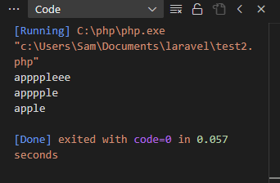

**Ans.to the question no 2**

<?php

function Concatenate($a,$b){

   echo $a.$b;

}

$str1 = "My name is ";

$str2 = "Sabbir";

Concatenate($str1,$str2);

**Output:**

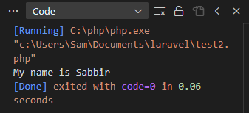

**Ans.to the question no 3**

<?php

$a = array("apple", "apppple", "appppleee");

$b = array_shift($a);

$c = array_pop($a);

print_r($a);

**Output:**

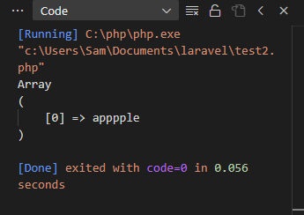

**Ans.to the question no 4**

$input1 = "Hello World";

$input2 = "Roll no 21";

function checkLetterWhitespace($str)

{

    return preg_match('/^[A-Za-z\s]+$/', $str);

}

if (checkLetterWhitespace($input1)) {

    echo "Contains only letter and whitespace. \n";

} else {

    echo "Doesn't contains only letter and whitespace.";

}

if (checkLetterWhitespace($input2)) {

    echo "Contains only letter and whitespace.";

} else {

    echo "Doesn't contains only letter and whitespace. \n";

}

**Output:**

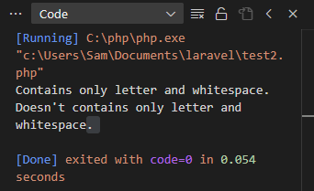

**Ans.to the question no 5**

function SecondMax(array $arr) {

   if(empty($arr)) {

       return;

   }

   $max = PHP_INT_MIN;

   $max2 = PHP_INT_MIN;

   foreach($arr as $n) {

       if($n > $max) {

           $max2 = $max;

           $max = $n;

       }

       if($n > $max2 && $n < $max) {

           $max2 = $n;

       }

   }

   return $max2;

}

$arr = array(70, 4, 8, 10, 14, 19, 7, 6, 5, 3, 2);

$second_maximum = SecondMax($arr);

echo "Second largest number ".$second_maximum;

